Alex Kelly
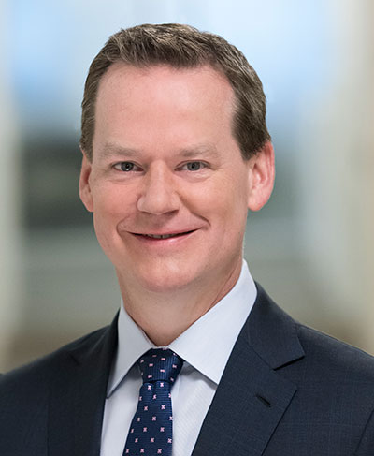
EVP & Chief Communications Officer

Alex Kelly is the EVP, Corporate Affairs and Chief Communications Officer, and has served in this role since April 20, 2015. Previously, Mr. Kelly served as Senior Vice President, Chief Integration Officer since July 2014. In this role, he led the integration of Forest Laboratories following its acquisition by Actavis. He also co-led the integration of Allergan. Prior to joining Actavis, Mr. Kelly was Senior Vice President, Chief Communications Officer, Public Affairs and Investor Relations at Forest Laboratories. In that role, he led Forest’s corporate communications and investor relations programs. While at Forest, Mr. Kelly led the integration of Aptalis Pharma following its acquisition in January 2014.

Prior to Forest, Mr. Kelly served as Vice President, Investor Relations at Bausch + Lomb. Mr. Kelly was Senior Vice President, Investor Relations at Merck & Co., Inc. following the combination with Schering-Plough where he led the Global Communications and Investor Relations team. He previously worked for Novartis as Executive Director, Investor Relations, after spending 14 years at Pharmacia, including ten years in pharmaceutical sales and sales management and four years in investor relations.

Mr. Kelly currently serves on multiple Boards and Committees, including the California Biomedical Innovation Alliance, The Allergan Foundation, and the HealthCare Institute of New Jersey. He earned his Bachelor of Science in Pharmacy from Purdue University, where he graduated Cum Laude.

