C. David Nicholson, PhD
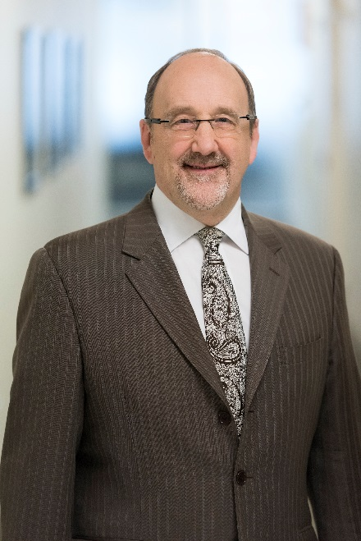
EVP & Chief R&D Officer

David Nicholson is the Chief R&D Officer, and has served in this role since March 2015. Dr. Nicholson joined the company (then Actavis) as Senior Vice President, Global Brands R&D in August 2014. He has been in research and development in the pharmaceutical industry since 1978.

Previously, he served as Chief Technology Officer and EVP, R&D for Bayer CropScience from March 2012 to August 2014; Senior Vice President of Licensing and Knowledge Management at Merck from 2009 to December 2011; and Senior Vice President, responsible for Global Project Management and Drug Safety at Schering-Plough from 2007 to 2009. From 1988 to 2007, Dr. Nicholson held various leadership positions at Organon, where he most recently served as Executive Vice President, R&D and was a member of the company’s Executive Management Committee.

Dr. Nicholson earned his B.Sc. from the University of Manchester and his Ph.D. from the University of Wales.

