Karen L. Ling, Esq.
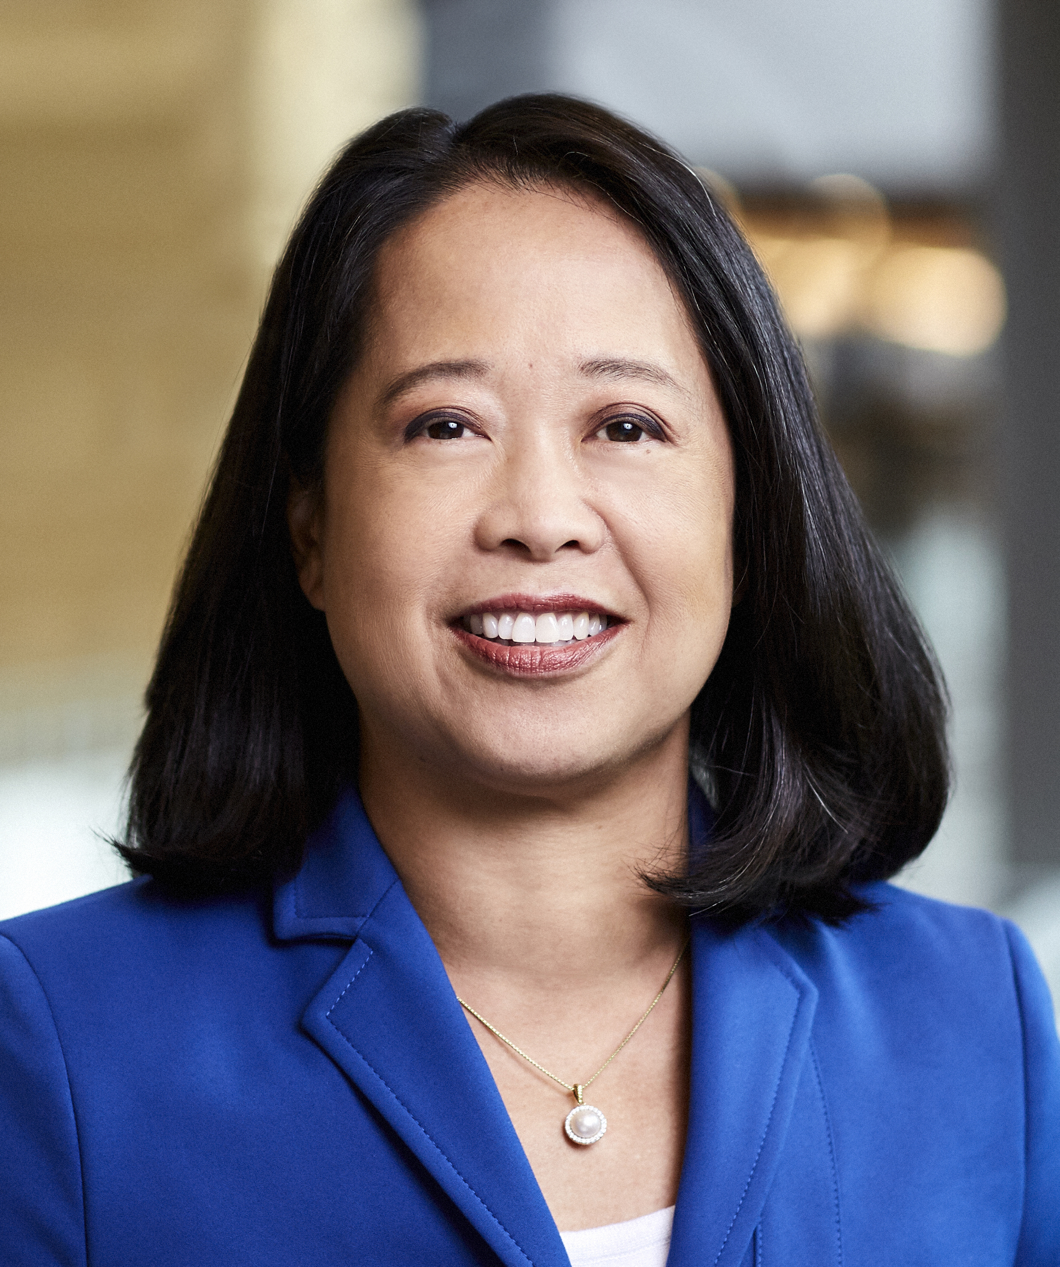
EVP & Chief Human Resources Officer

Ms. Ling is Executive Vice President and Chief Human Resources Officer of Allergan, and has served in this role since July 2014, having served as Senior Vice President and Chief Human Resources Officer at Forest from January 2014 to July 2014, prior to its acquisition by Allergan (then known as Actavis).

Ms. Ling joined Forest from Merck & Co., where she served as Senior Vice President, Human Resources for the company’s Global Human Health and Consumer Care businesses worldwide beginning in November 2011. Previously, she served as Vice President, Compensation and Benefits at Merck and Group Vice President, Global Compensation & Benefits at Schering-Plough (which was acquired by Merck). Prior to joining Schering-Plough in 2008, Ms. Ling spent 14 years at Wyeth Pharmaceuticals in various positions of responsibility in human resources and in Wyeth’s Labour and Employment Department. Before joining Wyeth, Ms. Ling was an attorney at Goldstein and Manello, P.C. in Boston.

Ms. Ling serves on the Board of Directors of the Glaucoma Foundation, Inc., The Jed Foundation and The Allergan Foundation. Ms. Ling received her J.D. from Boston University School of Law and a B.A. from Yale University.

