Kellie Sears
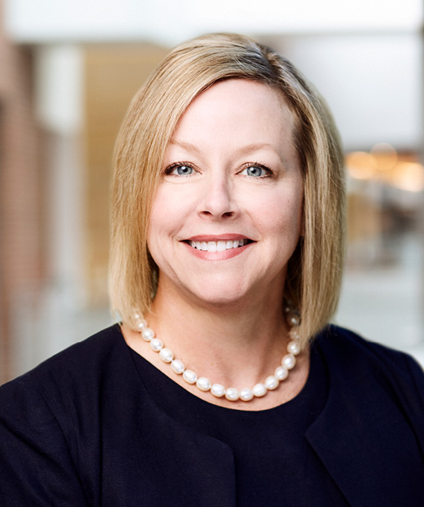
SVP & Interim Chief Human Resources Officer

Ms. Sears is SVP & Interim Chief Human Resources Officer and started in this role in July 2019, previously she served as VP, Human Resources Operations since July 2014. She held various HR roles from June 2012 through June 2014 with Forest prior to its acquisition by Allergan.

Ms. Sears joined Forest from Pfizer, where she spent thirteen years in a variety of roles, including leading its Global HR Shared Services function. Previously, Kellie’s career was focused in finance with various companies including Monsanto, Clark Refining & Marketing, and Corporate Express.

She holds a B.S. in Business Administration with an emphasis in Accounting from the University of Missouri and is a Certified Public Accountant (inactive).

