Maria Teresa Hilado
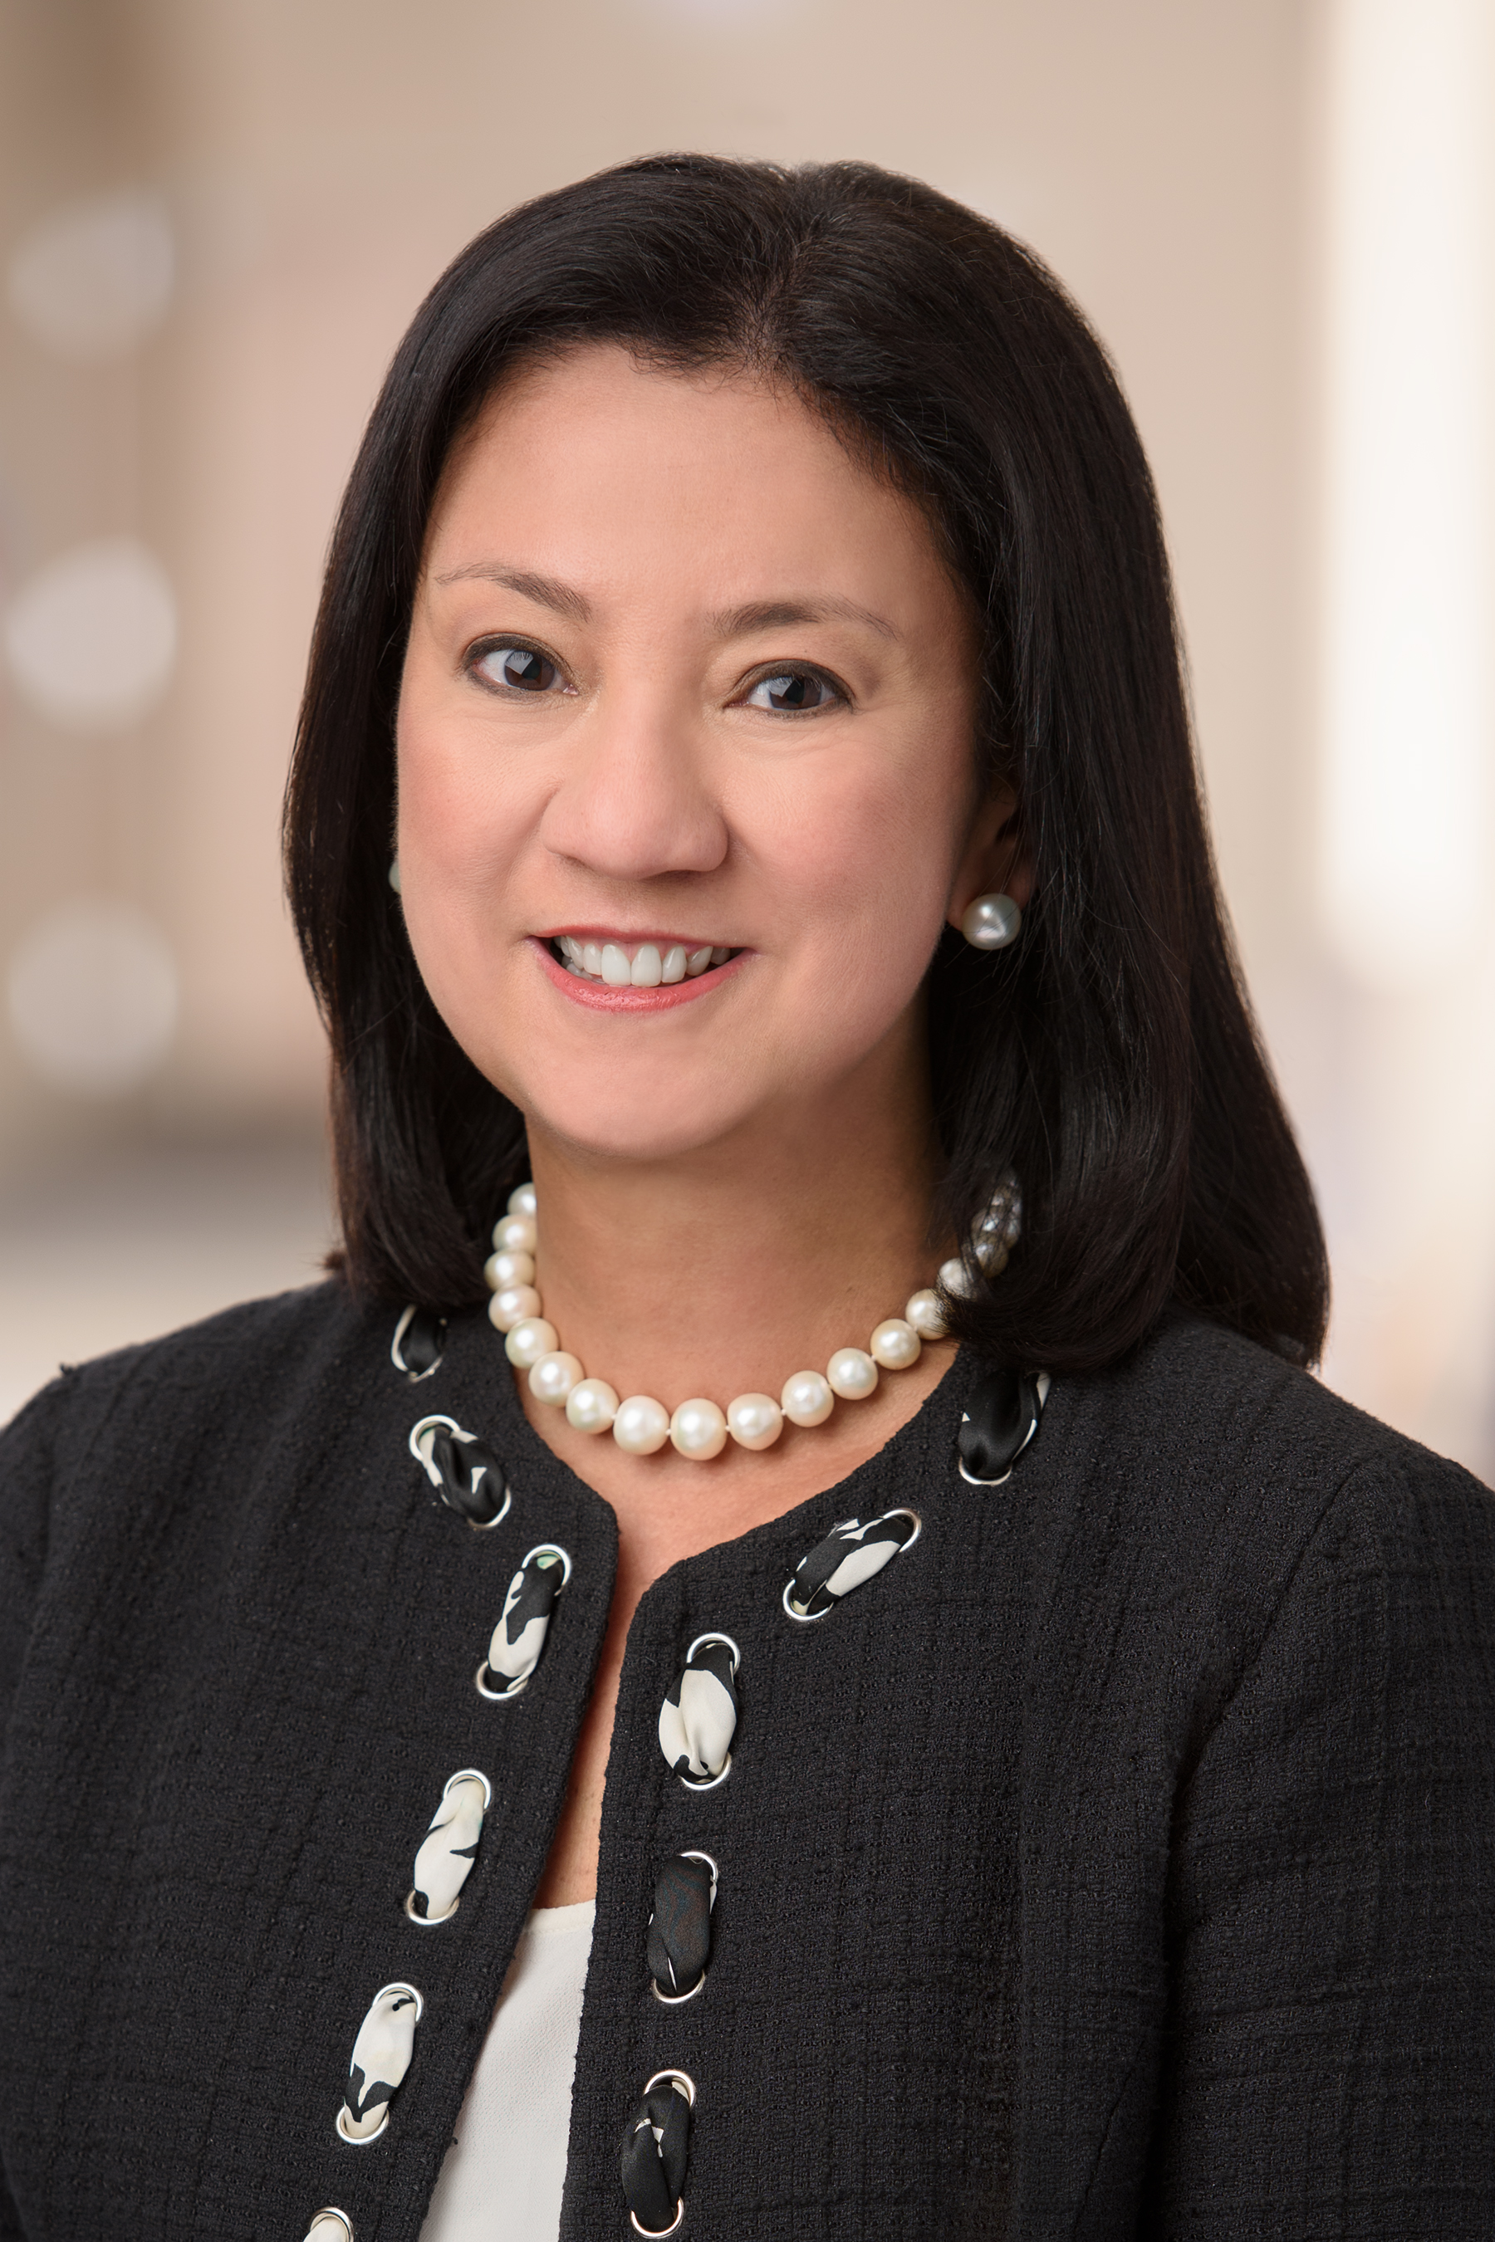
EVP & Chief Financial Officer

Tessa Hilado is the Chief Financial Officer, and has served in this role since December 2014 (then Actavis).

Ms. Hilado has 30 years of global finance experience. Prior to joining the company, Ms. Hilado served as Senior Vice President, Finance and Treasurer of PepsiCo, Inc. from 2009 to 2014. Before joining PepsiCo, she served as Vice President and Treasurer for Schering-Plough Corporation from 2008 to 2009. Before joining Schering-Plough, Ms. Hilado spent more than 17 years with General Motors Corporation in leadership roles of increasing responsibility, most notably Assistant Treasurer from 2006 to 2008 and CFO, GMAC Commercial Finance LLC from 2001 to 2005. She began her career with Far East Bank and Trust Company, Manila, Philippines.

Ms. Hilado currently sits on the Board of Directors at H.B. Fuller, Co. She earned her bachelor’s degree in Management Engineering from Ateneo de Manila University in the Philippines, and an MBA from the University of Virginia’s Darden School of Business Administration.

