Rob Stewart

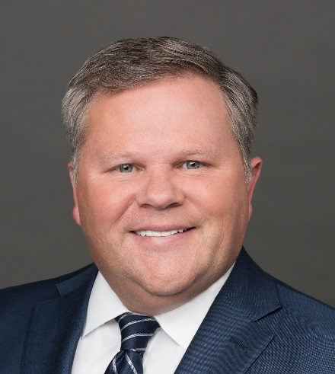

EVP, Chief Operating Officer, Allergan

Rob Stewart is the Chief Operating Officer, and has served in this role since May 2016. Prior to his current appointment, Mr. Stewart served as President, Generics and Global Operations from March 2015 to May 2016; Chief Operating Officer from July 2014 to March 2015; and President, Global Operations, from August 2010 to July 2014. He joined the company (then Watson) in November 2009 as Senior Vice President, Global Operations.

Mr. Stewart has 20 years of experience in global biopharmaceutical leadership, with expertise in all aspects of quality, manufacturing and supply chain management. Before joining Watson, Mr. Stewart held various positions with Abbott Laboratories, Inc. from 2001 until 2009 where he most recently served as Divisional Vice President, Global Supply Chain, Quality Assurance and prior to this position served as Divisional Vice President for U.S./Puerto Rico and Latin America Plant Operations. Preceding his time at Abbott Laboratories, Inc., he worked for Knoll Pharmaceutical Company from 1995 to 2001 and Hoffman La-Roche Inc.

Mr. Stewart has been a North American Manufacturing board member since September 2016. He earned his Bachelor's degree in Business Management and Finance from Fairleigh Dickinson University.

