William Meury
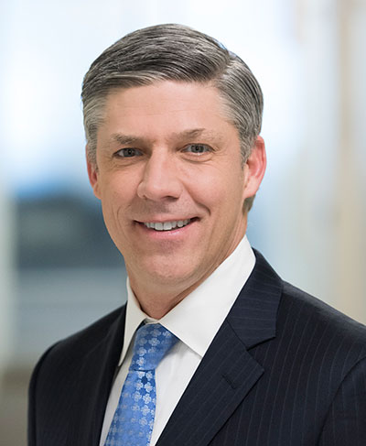
EVP & Chief Commercial Officer

Bill Meury is the Chief Commercial Officer, and has served in this role since May 2016. Mr. Meury previously served as President, Branded Pharma from March 2015 to May 2016. He joined the Company (then Actavis) in July 2014 as Executive Vice President, Commercial, North American Brands. He has significant experience in launching and commercializing healthcare products.

Prior to joining Actavis, Mr. Meury served as Executive Vice President, Sales and Marketing at Forest Laboratories, Inc. He joined Forest in 1993 and held multiple roles of increasing responsibility in Marketing, New Products, Business Development, and Sales. Before joining Forest, Mr. Meury worked in public accounting for Reznick Fedder & Silverman and in financial reporting for MCI Communications.

Mr. Meury is currently on the Board of Directors of several organizations, including The Jed Foundation, International Council of Ophthalmology Foundation, and The Allergan Foundation. Mr. Meury earned his bachelor’s degree in Economics from the University of Maryland.

